Convex-Hull Problem by Brute Force
Convex Set
A set of points (finite or infinite) in the plane is called convex if for any two points p and q in the set, the entire line segment with the endpoints at p and q belongs to the set.
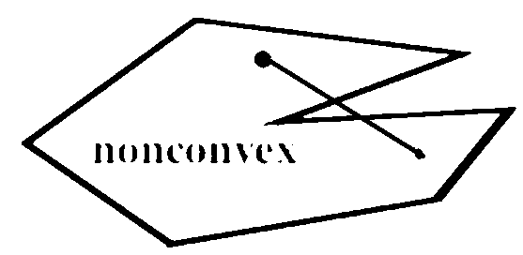
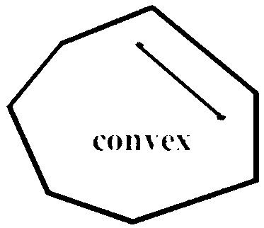

More examples on polygons for Convex and Non Convex:
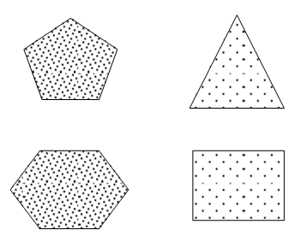
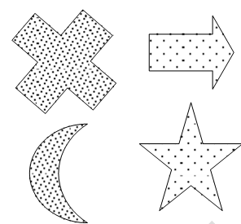

a. Convex Sets b. Sets that are not Non Convex

All the sets depicted in Figure (a) are convex, and so are a straight line, a triangle, a rectangle, and, more generally, any convex polygon, a circle, and the entire plane.
On the other hand, the sets depicted in Figure (b), any finite set of two or more distinct points, the boundary of any convex polygon, and a circumference are examples of sets that are not convex.
Take a rubber band and stretch it to include all the nails, then let it snap into place. The convex hull is the area bounded by the snapped rubber band as shown in the following Figure.
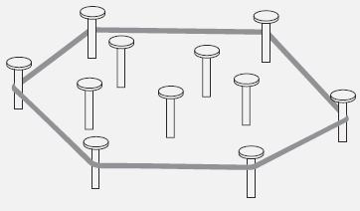

Figure c. Rubber-band interpretation of the convex hull

Convex hull
The convex hull of a set S of points is the smallest convex set containing S. (The smallest convex hull of S must be a subset of any convex set containing S.)
If S is convex, its convex hull is obviously S itself. If S is a set of two points, its convex hull is the line segment connecting these points. If S is a set of three points not on the same line, its convex hull is the triangle with the vertices at the three points given; if the three points do lie on the same line, the convex hull is the line segment with its endpoints at the two points that are farthest apart. For an example of the convex hull for a larger set, see Figure 2.3.

Theorem
The convex hull of any set S of n>2 points not all on the same line is a convex polygon with the vertices at some of the points of S. (If all the points do lie on the same line, the polygon degenerates to a line segment but still with the endpoints at two points of S.)
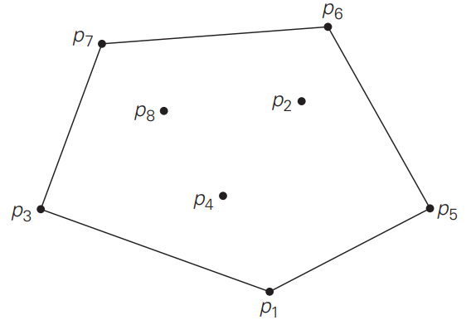

Figure d. The convex hull for this set of eight points is the convex polygon with vertices at p1, p5, p6, p7, and p3.
The convex-hull problem is the problem of constructing the convex hull for a given set S of n points. By identifying “extreme points” we can solve convex hull problem. An extreme point of a convex set is a point of this set that is not a middle point of any line segment with endpoints in the set.

Some examples with extreme points are,
- The extreme points of a triangle are its three vertices
- The extreme points of a circle are all the points of its circumference
- The extreme points of the convex hull of the set of eight points in Figure d are p₁, p₅, p₆, p₇, and p₃.
Application
Extreme points have several special properties, but other points of a convex set do not have. One of them is exploited by the simplex method, This algorithm solves linear programming Problems. The extreme points are listed in a clockwise or a counter clockwise order.

Time efficiency of this algorithm.
Time efficiency of this algorithm is in O(n³): for each of n(n − 1)/2 pairs of distinct points, we may need to find the sign of ax + by – c for each of the other n − 2 points.

